# IT Support Simulation – Service Desk & Ticketing

## Overview

This project was completed as part of the ICTSAS527 unit (Manage Client Problems). It simulates working as an IT Support Officer in the Service Delivery team at ITWorks, handling service desk calls and resolving client ICT issues for both ITWorks staff and an external client, Albion Bay Council library staff.

## Tools & Environment

- Windows 10 virtual machines  
- Firefox web browser troubleshooting  
- File system management (copying, permissions, storage)  
- Performance troubleshooting (slow PC response)  
- iTop Service Desk system for incident logging

## Key Tasks Completed

### 1. Manage ITWorks Problem (Firefox – Offline Mode)

• Reviewed and analysed client problem reported by Vera Zilko on behalf of CEO Xander Alesario.  
• Identified Firefox set to 'Offline Mode' as the root cause of browser connectivity issues.  
• Logged the incident in iTop, planned resolution steps, and implemented fix.  
• Verified resolution by accessing websites (reddit.com, abc.net.au).   
• Communicated solution and sought client feedback.

#### Screenshots

Email confirmation:

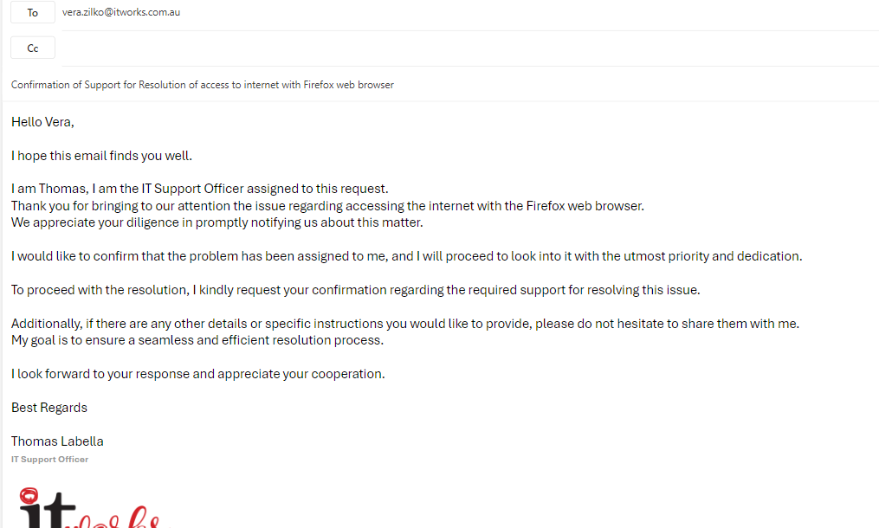

iTop ticket logs:

Plan and Outcome:

Ticket resolved:

### 2. Manage Albion Bay Council Library Problem (File Copy & Performance)

• Analysed reported issues with copying a video file and PC slowness for library staff member Quinn Gage.  
• Determined root causes: D drive had insufficient space and a test application consumed excessive CPU/RAM.  
• Logged incident in iTop, created a resolution plan, and implemented fixes.  
• Verified by copying video file successfully to D drive, playing video in VLC, and checking Task Manager performance tab.  
• Provided resolution confirmation and followed up with client feedback procedures.

#### Screenshots

Insert here: iTop ticket logs, D drive video file, VLC playback, Task Manager performance tab.

Ticket logged in the system:

Plan & Implementation:

Updated ticket with tests, actions performed and outcome:

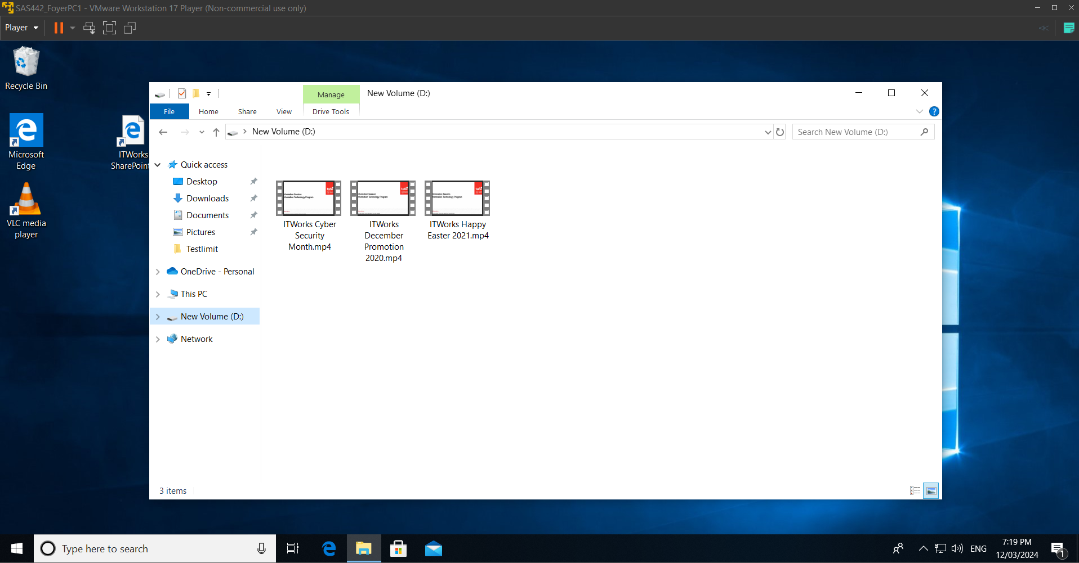

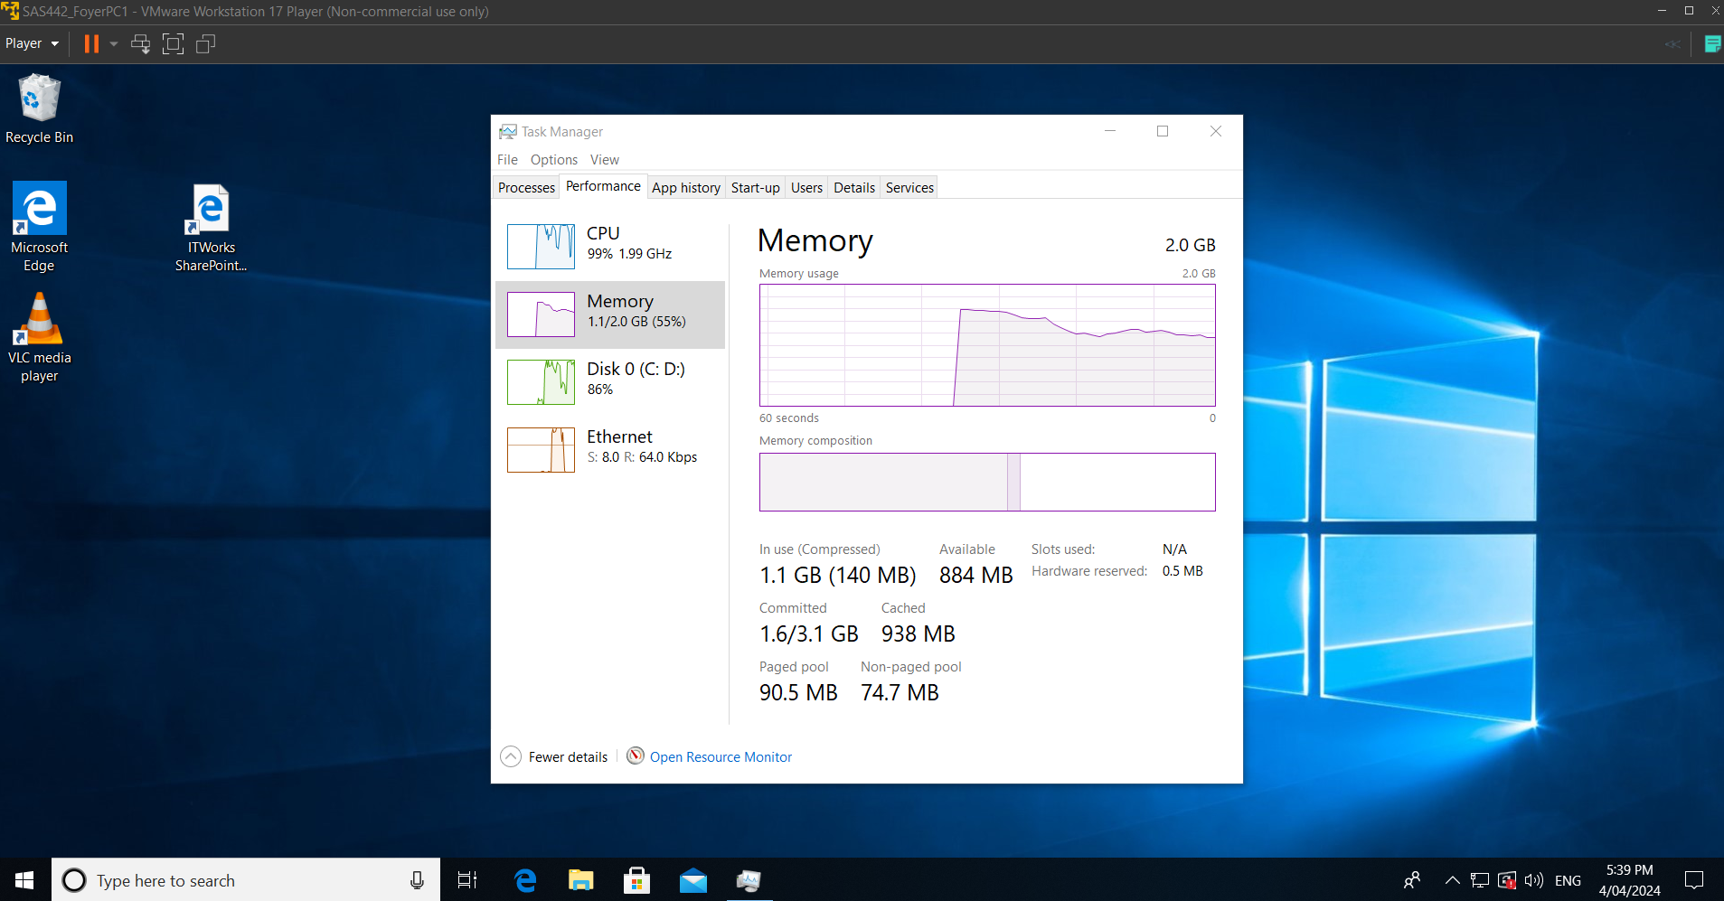

Ticket resolved:

## Skills Demonstrated

- Incident logging and ticket management  
- Troubleshooting browser connectivity and network settings  
- File system permissions and storage management  
- PC performance optimisation  
- Clear communication with end-users  
- Following IT service desk procedures

## Outcome

Successfully resolved service desk issues for both ITWorks and Albion Bay Council clients. Provided end-user documentation, confirmed solutions with clients, and applied feedback procedures. Demonstrated ability to manage IT support tasks using structured problem-solving and communication.